1. App name: movieexplorer (v1.0.0)
This is the project's identity, stored in package. Json and package-lock. Json.
. asya ine an name san app gin gagamit ine sa npm pati expo para ma identify an app an number (1.0.0) version ine siya sa app. Nag tataas an number pag nag uupdate or gin uupay an bug.
2. Framework: Expo SDK 57 + React Native 0.86
- React Native gin gagamit para mag create ungod na mobile app gamit an JavaScript. (View, Text, Pressable, at TextInput) ine sila ay nagging part na gin gagamit na sa Android pati IOs
- Expo naman asya ine siya an toolkit para bumulig sa ReactNative para mag setup,mag run sana para dire mo na need an Android Studio o Xcode para mag-test.
- npx expo start naman command ine siya para mag run an app. Expo Go ay app sa phone. An SDK 57 / 0.86 naman kay an mga version number. Ang SDK (Software Development Kit) kay colletion sa mga tool ng Expo, an every version ng Expo ay may tama na version sa React Native .Sa kuan naman expo-router: authomatic na gin hihimo home screen ang src/app/index.js.

1.The app's memory: 5 useState variables (lines 13–17)
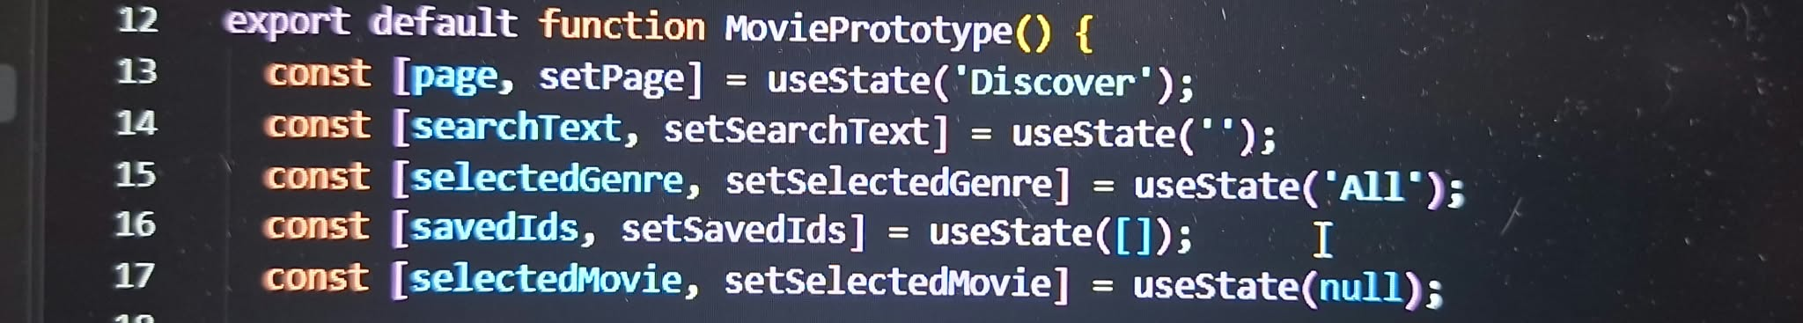
useState is how the app remembers things while it's open. Each line has two parts: the value (like page) and the function that changes it (like setPage).
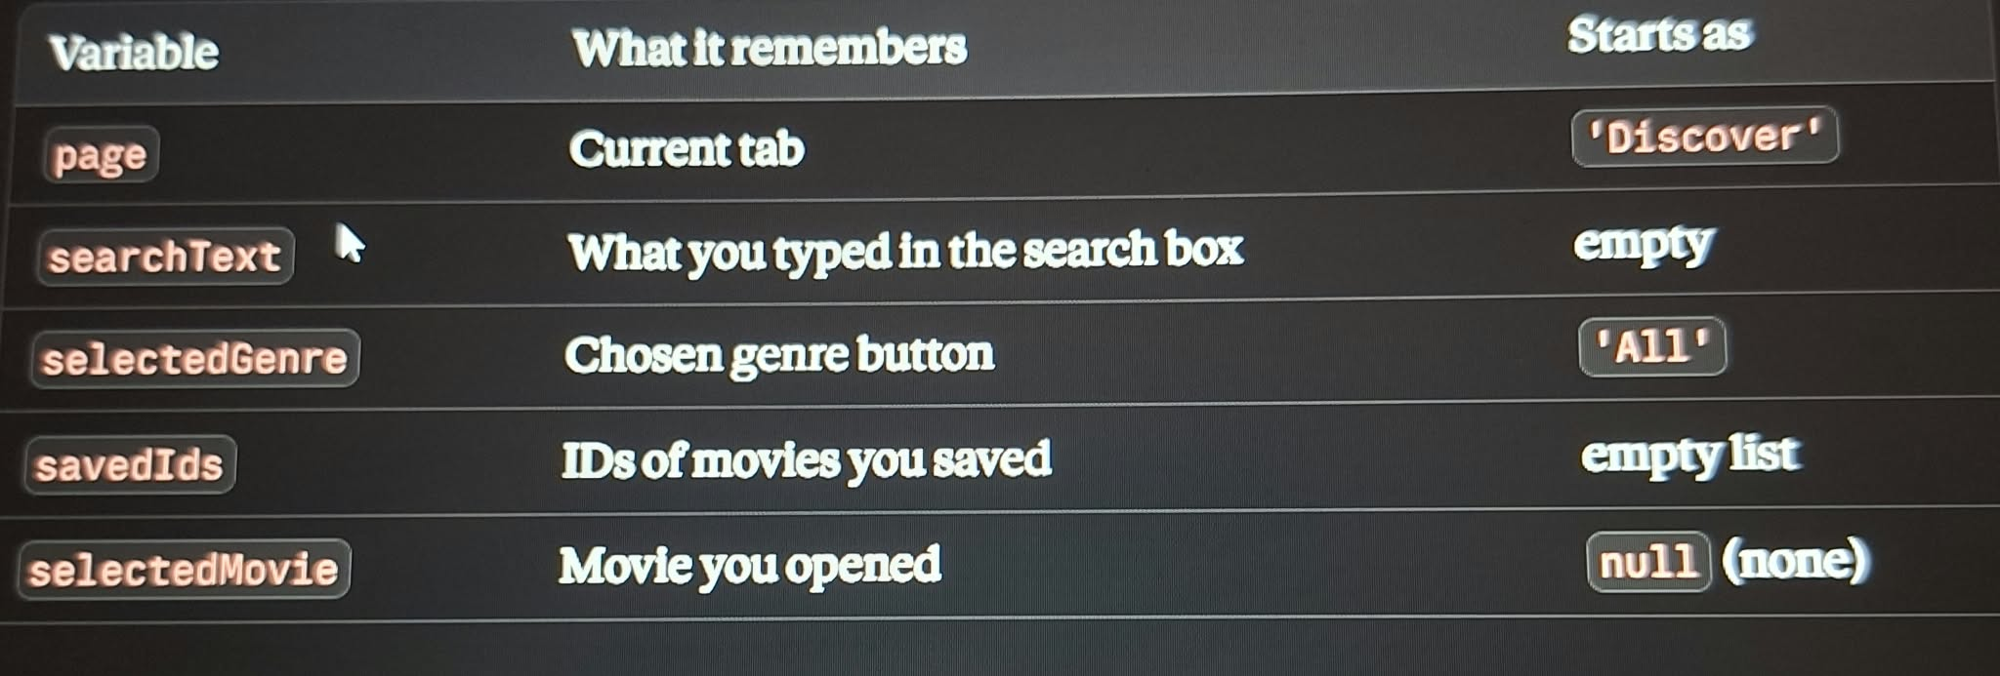
When any of these changes, the screen updates automatically
2. Search, genre filter, and watchlist in one filter() (lines 19–24)
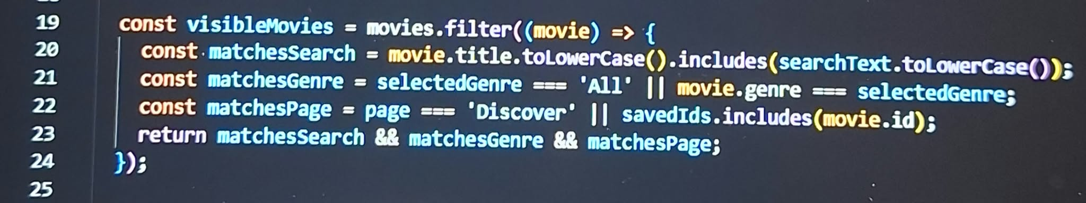
This decides which movies to show. It checks every movie in the list and keeps only those that pass all three tests:
- matchesSearch: the title contains what you typed. toLowerCase() ignores capital letters, so "inception" matches "Inception".
- matchesGenre: the genre matches your choice, or you chose "All".
- matchesPage: on Discover, every movie passes. On Watchlist, only saved movies pass.
&& means all three must be true. The result is stored in visibleMovies
3. Save or remove a movie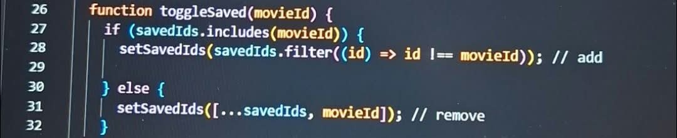
- Kung ang movie ngani naka save na gin tatangal it. filter((id) => id !== movieId) kay ginbibilin ang tanan ID except sa imong movie na gin hiling.
- If it's not saved, add it. An [...savedIds, movieId] gin copy niya n old list tapos gin bubutang sa bag’o na Id sa katapusan.
4. Switching tabs
This runs when you tap DISCOVER or WATCHLIST. It closes the details page, clears the search, resets the genre, and then opens the tab you chose.
5. Conditional rendering (the "no navigation library" trick)
Conditional rendering means the app shows different things depending on a condition. It's like asking "if this is true, show this, otherwise show that."
Your app has no separate screens. It uses one screen and swaps what's shown with ? : and &&.

6. Showing the movie cards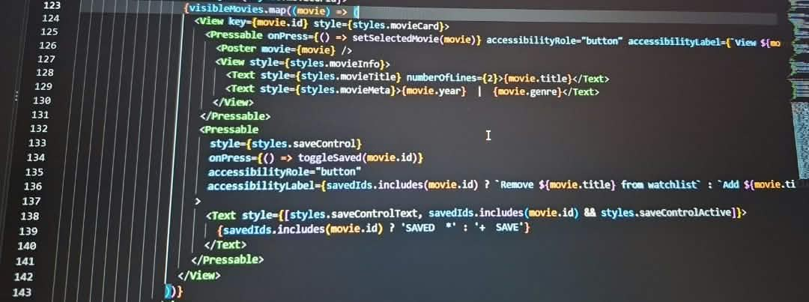
.map() creates one card for each movie in visibleMovies. Each card has:
- a tappable area (poster, title, year, genre) that opens the details page with setSelectedMovie(movie)
- a + SAVE button that calls toggleSaved
key={movie.id} gives each card a unique ID so React can track it. The genre buttons are made the same way from the genres list.
7. The Poster component
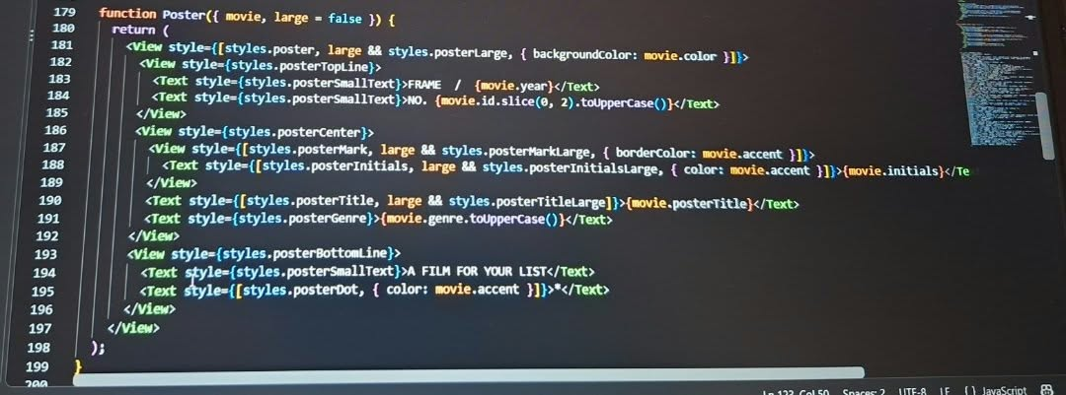
A component is a reusable piece of the screen. The app has no image files. Poster draws each poster using View and Text, with the movie's own colors, initials, and title.
The large option makes it bigger on the details page. The same code is used for the small cards and the big poster.

